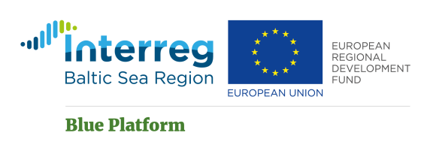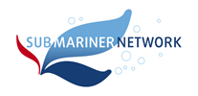

# Blue Platform: Mapping perspectives of the blue bio-economy in the Baltic States, 26 November 2020

Draft agenda

***On-line workshop***

|  |  |
| --- | --- |
| **Time** | **Agenda item** |
| 10:00­-10:10 | Welcome, introduction to workshop and SUBMARINER Network/Blue Platform project.  Anda Ikauniece, Angela Schultz-Zehden |
| 10:10-10:55 | Presentations on status and achievements in blue bio-economy in the Baltic States  Moderator Andrius Sutnikas, Klaipeda Science and Technology Park (tbc)   * Estonia: Georg Martin, Estonian Marine Institute. * Latvia: Elita Benga, Institute of Agricultural Resources and Economics. * Lithuania: Nerijus Nika, Klaipeda University Aquaculture Competence Centre.   Topics to be covered (but not limiting):   * Energy – wind, waves, solar, biomass, including beach cast; * Aquaculture – fish, shrimps, mussels or IMTA, RAS; * Biotechnology – based in marine resources or serving aquatic needs; * Sustainable use of resources and circular economy.   *Time frame - 3 presentations 15 min. each* |
| 10:55-11:40 | Inspiring and valuable experience from other Baltic Sea countries  Moderator Liisi Lees, University of Tartu  • Finland on complete use of aquatic biomass: Sari Mäkinen, LUKE;  • Germany on multi-use of marine space, esp. wind parks: Ivana Lukic, SUBMARINER Network;  • Denmark on jellyfish as new bioresource: Jamileh Javidpour, South Denmark University.  *Time frame – 3 presentations 15 min. each* |
| 11:40-11:50 | **Comfort break** |
| 11:50-12:20 | Moderated panel discussion  Moderator Anda Ikauniece, LIAE  • energy – are there obstacles for wider use of non-fossil resources; - are technologies in place for upscaling from experiment-size production; - is MSP helpful in development?  • aquaculture – is Baltic Sea feasible for aquaculture development? – should Baltic States go for development stage-based aquaculture in RAS; - should it be fish, mussels, algae? Local or non-local species? – is MSP helpful in aquaculture development?  • biotechnology – are we aware of all possible uses of Baltic Sea resources; - do we have enough effective knowledge transfer from research to entrepreneurship;   * sustainable use of resources and circular economy – is knowledge in place for sustainable use; - would waste and plastic waste circulation from the sea work?   *Panelists – speakers + 1 more from each of the Baltic States*  *Participants of the workshop will receive a report with compilation of ideas discussed and will be invited to comment on the report for 2 weeks.* |